# How to download and install Plumeria.

Plumeria is a program that calculates the ascent of volcanic plumes. It will be used for the CIDER exercises. There are two versions available:

1. A Visual Basic version, which includes a graphical user interface. It runs only on Windows machines, but you can run it on a Mac if you install a Windows virtual machine. See section 2.0 below for instructions.
2. A Fortran version that is platform-independent. Simulations are run at the command line and output is plotted using a script that runs in Matlab or Octave. You will need a fortran compiler to run this version. And you will need Matlab or [Octave](https://www.gnu.org/software/octave/) to plot the output.

# 1.0 Download and install the Visual Basic version:

To use it, you will need A computer running Microsoft Windows, version 7 or later, and a few megabytes of storage space.

1. Download the file "plumeria_2.3.2.zip" from the vhub web site <https://vhub.org/resources/1194/supportingdocs>
2. and unzip it
3. Double-click on the "setup.exe" icon (or, if you need to log in as an administrator, right-click on "setup.exe" and choose "run as administrator". Then log in with your Admin credentials.
4. 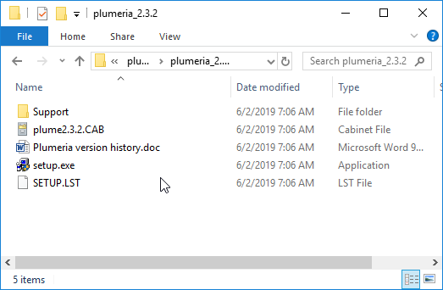

double-click (or right-click and choose “run as administrator”)

1. When the screen “Welcome to the Plumeria 2.3.2 installation program” appears, click “okay”
2. When the “Plumeria 2.3.2 setup” dialog box appears, click the large icon on the upper left to start the setup.
3. On the “plumeria 2.3.2 program group name, choose “continue”

After setup is complete, on Windows 7 and 8, you will find Plumeria 2.3.2 in your start menu. On Windows 10, you will have to navigate to “c:\Program files (x86)\Plumeria 2” to find the executable “plume2.3.2.exe”. I suggest that you create a shortcut with the program and place the shortcut on the desktop.

# 2.0 Download and install a virtual Windows machine on your Mac to run the Visual Basic version

If you have a Mac and would like to run the Windows version of plumeria, you can do it by installing a Windows virtual machine, as follows:

1. Download Virtual Box (<https://www.virtualbox.org/>)

2. Download the Windows 10 virtual machine formatted for Virtual Box (or Win 7, 8, depending on your preference) from Microsoft website (the file is ~7GB and took 10 min on my home internet. We could just distribute this to participants via a flash drive if you want to speed things up):

<https://developer.microsoft.com/en-us/microsoft-edge/tools/vms/>

3. In Virtual Box, go to File -> Import Appliance, then locate the pre-configured Windows VM that you just downloaded (filename should be something like MSEdge - Win10.ovf)

4. Once you launch the VM, the password is: Passw0rd!

5. Now you should have a fully functional windows OS.

6. Follow the Plumeria instructions in Section 1.0, above.

# Download and install the Fortran version

This version will work on all platforms, but you will need a computer with a Fortran compiler. Below are the set of commands you will use, assuming you are running a CentOS Linux computer. Names starting with a dollar sign (e.g. $NEWDIR) are variable names; change them to a name you will use.

1) Download the zipped software package “plume_fort_v2.3.1.zip” from <https://vhub.org/resources/1197/supportingdocs>, and place it in a new directory ($NEWDIR)

2) Move to $NEWDIR, unzip it, and compile it:

cd $NEWDIR

unzip plume_fort_v2.3.1.zip

make

*(note that the makefile assumes you are compiling with gfortran, located in /usr/bin. If you are using another fortran compiler, or wish to use other compilation flags, modify line 9 in the makefile)*

3) Try a test run, using the input file default.inp, in the input subdirectory.

./plumeria input/default.inp

*This should run the model, writing a table of plume properties as a function of elevation in the plume to the monitor screen, and create an output file called “default_params_out.txt” in the output folder. It should be identical to the file “default_params_out_example.txt” in the same folder.*

4) If you have Matlab (or Octave, on Linux), try plotting up the results.

1. Open the file “plotemup.m”
2. On line 5, change to “n_outfiles=1”. This is the number of output files you will read. If you do another run and want to plot them both, change to “n_outfiles=2”. You can plot up to 5 output files.
3. On line 6, change to “outputfile1=$NEWDIR/output/default_params_out.txt”.
4. On line 7, change to “filelabel = ‘default params’”. This is the label that will appear in the legend when it’s plotted. If you want to plot more than one curve, make corresponding changes to lines 8 and 9 for outfile2, and add lines if necessary for outputs 3, 4, 5, etc.
5. Save and run the script. You will get a plot that looks like this:

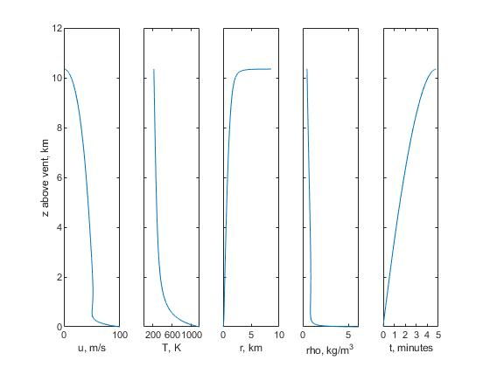

If you change line 5 to “n_outfiles=2”, it will also plot results from the file “Redoubt_200903231200Z_out.txt” in the output folder:

